Table of Contents
Unit 7 Consolidate Task with SQL Queries 2
Database Name 2
Table 1: Crews 2
Create Table Query 2
Insert 5 Rows Query 2
Check Data Query 3
Expected Output 3
Table 2: Missions 3
Create Table Query 3
Insert 5 Rows Query 4
Check Data Query 4
Expected Output 4
Table 3: Spacecrafts 4
Create Table Query 4
Insert 5 Rows Query 5
Check Data Query 5
Expected Output 5
Extra Query to Check All Tables 6
Extra Query to Count Rows 6
Explanation 6

Unit 7 Consolidate Task with SQL Queries

Database Name
CREATE DATABASE unit7_database;
USE unit7_database;

Table 1: Crews

Create Table Query
CREATE TABLE Crews (
id INTEGER PRIMARY KEY,
spacecraft VARCHAR(40),
astronaut VARCHAR(40)
);

Insert 5 Rows Query
INSERT INTO Crews (id, spacecraft, astronaut) VALUES
(1, 'Apollo 11', 'Neil Armstrong'),
(2, 'Apollo 11', 'Buzz Aldrin'),
(3, 'Apollo 11', 'Michael Collins'),
(4, 'Apollo 13', 'Jim Lovell'),
(5, 'Apollo 13', 'Fred Haise');
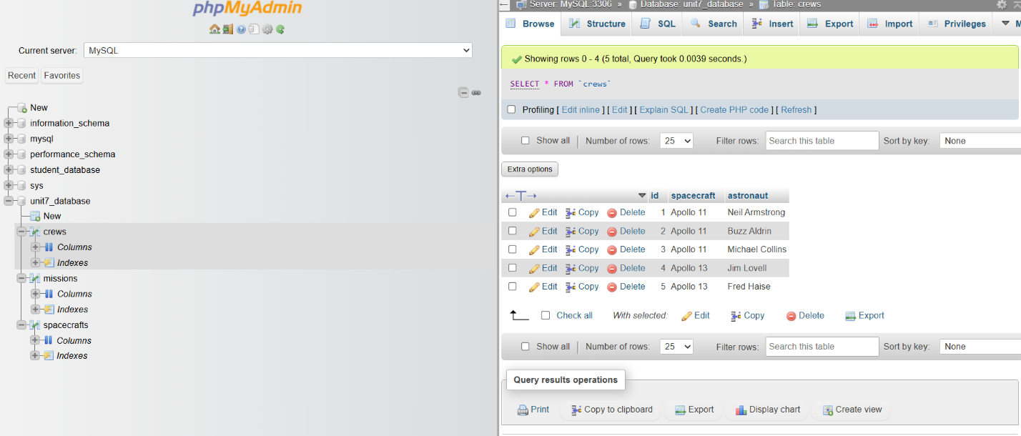

Check Data Query
SELECT * FROM Crews;

Expected Output
id | spacecraft | astronaut
1 | Apollo 11 | Neil Armstrong
2 | Apollo 11 | Buzz Aldrin
3 | Apollo 11 | Michael Collins
4 | Apollo 13 | Jim Lovell
5 | Apollo 13 | Fred Haise

Table 2: Missions

Create Table Query
CREATE TABLE Missions (
id INTEGER PRIMARY KEY,
spacecraft VARCHAR(40),
launch DATE,
recovery DATE,
destination VARCHAR(40)
);

Insert 5 Rows Query
INSERT INTO Missions (id, spacecraft, launch, recovery, destination) VALUES
(1, 'Apollo 11', '1969-07-16', '1969-07-24', 'Moon'),
(2, 'Apollo 13', '1970-04-11', '1970-04-17', 'Moon'),
(3, 'Apollo 14', '1971-01-31', '1971-02-09', 'Moon'),
(4, 'Apollo 15', '1971-07-26', '1971-08-07', 'Moon'),
(5, 'Apollo 16', '1972-04-16', '1972-04-27', 'Moon');
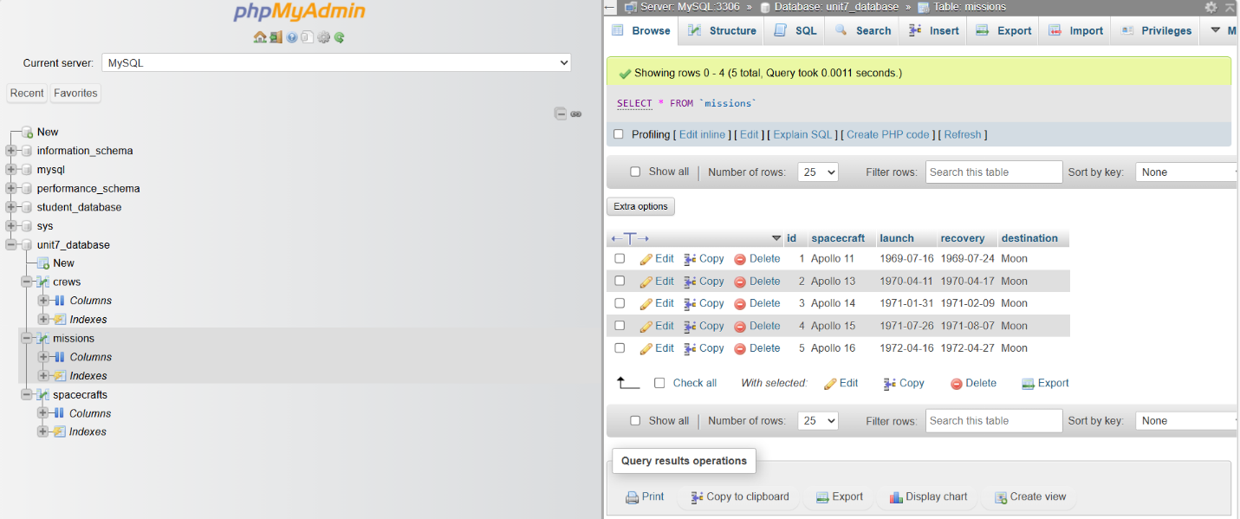

Check Data Query
SELECT * FROM Missions;

Expected Output
id | spacecraft | launch | recovery | destination
1 | Apollo 11 | 1969-07-16 | 1969-07-24 | Moon
2 | Apollo 13 | 1970-04-11 | 1970-04-17 | Moon
3 | Apollo 14 | 1971-01-31 | 1971-02-09 | Moon
4 | Apollo 15 | 1971-07-26 | 1971-08-07 | Moon
5 | Apollo 16 | 1972-04-16 | 1972-04-27 | Moon

Table 3: Spacecrafts

Create Table Query
CREATE TABLE Spacecrafts (
spacecraft_id INTEGER PRIMARY KEY,
spacecraft_name VARCHAR(40),
spacecraft_type VARCHAR(40)
);

Insert 5 Rows Query
INSERT INTO Spacecrafts (spacecraft_id, spacecraft_name, spacecraft_type) VALUES
(1, 'Apollo 11', 'Crewed lunar mission'),
(2, 'Apollo 13', 'Crewed lunar mission'),
(3, 'Apollo 14', 'Crewed lunar mission'),
(4, 'Apollo 15', 'Crewed lunar mission'),
(5, 'Apollo 16', 'Crewed lunar mission');
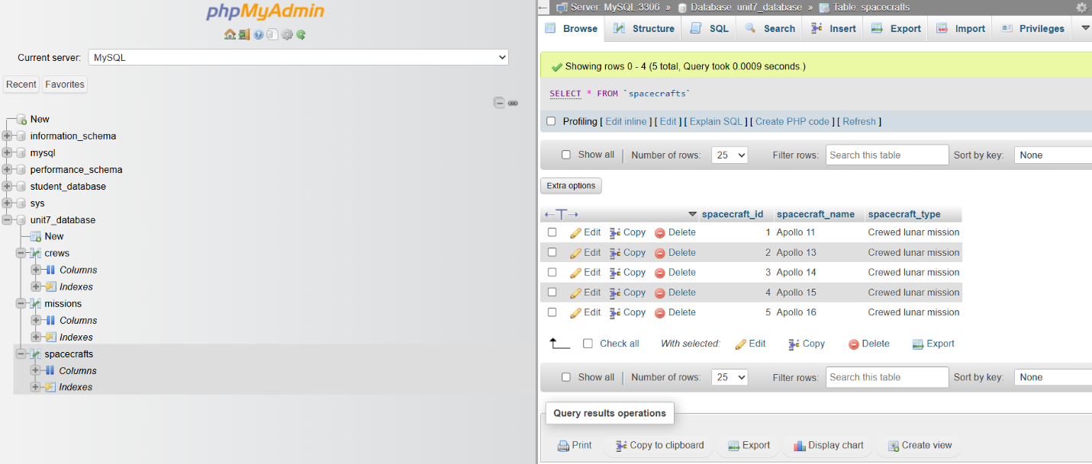

Check Data Query
SELECT * FROM Spacecrafts;

Expected Output
spacecraft_id | spacecraft_name | spacecraft_type
1 | Apollo 11 | Crewed lunar mission
2 | Apollo 13 | Crewed lunar mission
3 | Apollo 14 | Crewed lunar mission
4 | Apollo 15 | Crewed lunar mission
5 | Apollo 16 | Crewed lunar mission

Extra Query to Check All Tables
SHOW TABLES;

This should show:

Tables_in_unit7_database
Crews
Missions
Spacecrafts

Extra Query to Count Rows
SELECT COUNT(*) AS total_crews FROM Crews;
SELECT COUNT(*) AS total_missions FROM Missions;
SELECT COUNT(*) AS total_spacecrafts FROM Spacecrafts;

Each result should show:
5

Explanation
Unit7_database was the database used for the Unit 7 consolidate job. Three tables were created: Crews, missions, and spacecraft. Each table was augmented with five rows of precise test data. The data do not include personal information from classmates or family.
SQL queries were used to create the database, tables, test data, and successful data addition. The SELECT * queries imply that each table has five rows.

